Name | Date
Section
Instructions: Read the problem thoroughly and create the code for your solution. Do not forget to write comments in your solution. After you have created your solution, you can ask your G-ENGN1 laboratory professor to check your work.

This will count as an individual assignment for this course.

Store Explore

You have been assigned to build a dynamic storage mechanism for your team's game engine. This storage mechanism has the ability to store letters and numbers that will be used to identify game engine developers who are using your game engine.

Design

Template

The storage mechanism must use a template that has 3 characteristics: 2 numbers and 1 letter. The first number is used to identify the current instance of the template. The second number is used as the id for the game developer who uses your game engine. You can assign any value to that number, and cannot be changed by the game developer when your program runs. The letter is used to augment the identification of the game developer who is using your game engine.

The characteristics must be hidden from outsiders at all times, and you must create behaviors to set and retrieve those values. For example, there must a behavior to set the id of the template instance, and another behavior to get the id of the template instance.

Setup

Your program must create 3 dynamic instances of the template, and 1 dynamic template instance to be used as a pointer. Each of the first 3 dynamic instances must be represented by a pointer of the template. The fourth is used to point to any of the 1 of the first 3 dynamic instances, and will be called the main store pointer throughout this document. When the program starts, the main store pointer is pointing at nothing.

Functions

The program must use several functions to manipulate template instance pointers of the storage mechanism of your game engine. The functions are shown in table 1.

Function Name | Description
showMenu() | Tell the user what can be done with your program. The choices include setting values to the current selected store, change the current selected store, and show the values of the current selected store.
changeStore() | Accepts 4 arguments, and one of those will be used to change the value of the template instance pointer. The first 3 arguments will accept the first, the second, and the third template instance pointers used as the main stores. The fourth argument will accept the main store pointer that will be used to point to a main store. To do that, the following will be made by this function.  First, ask the user which of the 3 main stores would he like to be the current main store to be pointed by the fourth argument. He can select a main store out of the 3 using the id characteristic.  Next, the function will switch the fourth argument to point to the selected main store by the user.  Last, the function will return back to the caller.
setStore() | Accepts the main store pointer and that will be used to change the values currently represented by the argument of this function. The function will show the id of the object being represented by the argument, then ask the user for a letter and a number. The new letter and number will be assigned to the number and letter attributes of the object being pointed by the argument, then the function will return back to its caller.
showStore() | Shows the values of a main store in the console. Accepts a target main store as an argument.
Table 1. The storage mechanism main functions.

Implementation

Sequence

First, your program will call the showMenu() function to show the operations he can do with your program, and ask him which option he wants to use. Second, the selected option is implemented, calling either setStore(), changeStore(), or showStore(), and passing the required arguments to those functions. Last, your program will ask the user if he wants to continue using your program or not. If he chooses to exit, thank the user.

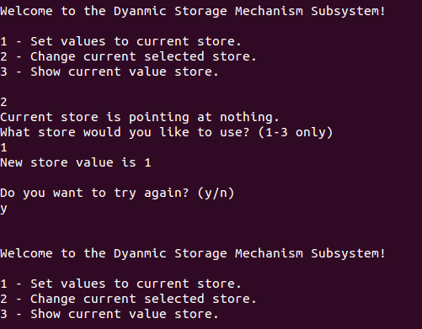

Figure 1.

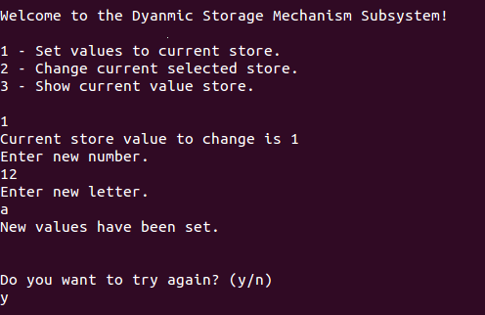

Figure 2. The first main store contains 12 and a, for number and letter respectively.

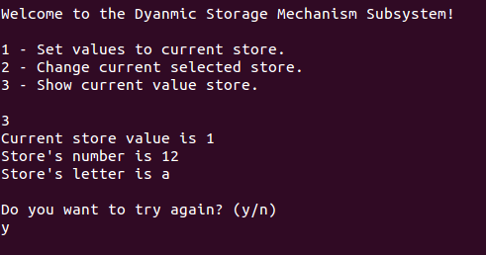

Figure 3. Showing the values of the main store pointer.

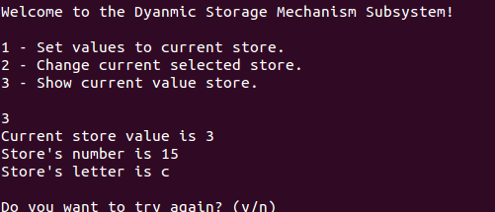

Figure 4. The third main store contains 15 and c, for number and letter respectively.

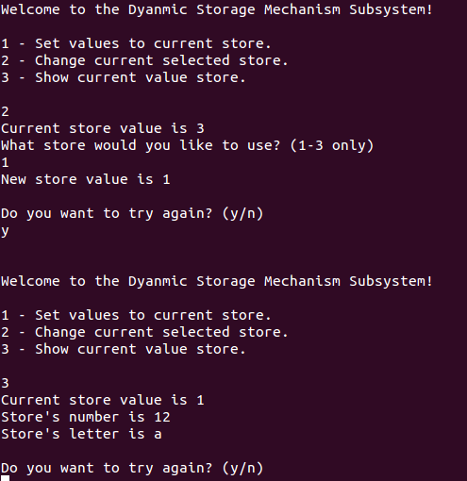

Figure 5. Main store pointer is pointing at the first main store dynamic instance and showing the values of that instance.

Powerful hint!

http://stackoverflow.com/questions/4623604/c-pointer-pass-by-reference-question

You may start writing your solution here.

